

Architectural and engineering specifications
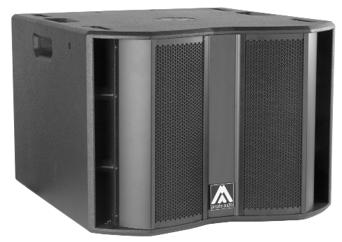
S15WP

• The system shall consist of a passive subwoofer enclosure. The enclosure shall feature a direct radiating 4-inch voice coil, neodymium magnet, 15-inch loudspeaker component, loaded in a bass-reflex tuned enclosure. Low frequency transducer shall be rated at a nominal impedance of 8 ohms.

• The usable bandwidth (using an external DSP) shall be 35Hz to 140Hz (-10dB).

• SPL, measured at 1W and 1m under free field conditions shall be 96 dB.

• Maximum SPL continuous, measured at 1m under free field conditions shall be 129 dB. Maximum SPL peak, measured at 1m under free field conditions shall be 132 dB.

• Continuous musical program shall be 2000W.

• Enclosure shall be bass-reflex type with lateral laminar ports.

• Enclosure cabinet construction shall consist of birch plywood. Dimensions shall be 630 mm (24.8 inch) wide, 463 mm (18.2 inch) high, 680 mm (26.8 inch) deep. Enclosure weight shall be 36.5 Kg.

• Enclosure cabinet finish shall consist of black matt high-resistance Polyurea® paint.

• The cabinet shall feature several M8 rigging points to fix an external rigging hardware.

• The front enclosure shall be protected by two 2mm steel grilles with acoustically transparent black technical mesh. The grille shall be secured via screws to keep it in place when facing the cabinet downwards.

• The cabinet shall feature a round socket with M20 thread located on the top panel to allow full-range enclosure coupling.

• Electrical connections shall be made via one of the two 4-pole NL4MP Speakon connectors with the following configuration: +1/-1 signal input, +2/-2 disconnected

• The loudspeaker system shall be the Amate Audio® NITID S15WP.
• The rigging accessories shall be the Amate Audio® ACR-M8.

December 2024

