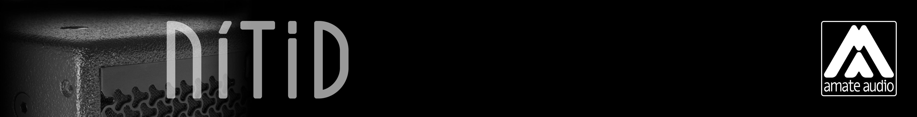
Architectural and engineering specifications

N12KTV

• The 2-way full range passive loudspeaker system shall have one direct radiating 12-inch low frequency transducer and one 1,75-inch voice coil diameter, PETP diaphragm neodymium magnet compression driver loaded onto an asymmetrical rotational horn. Low frequency transducer shall be rated at a nominal impedance of 8 ohms. High frequency transducer shall be rated at a nominal impedance of 16 ohms.

• The usable bandwidth shall be 70Hz to 20kHz (-10dB).

• The system’s horizontal coverage shall be 50º to 100º, with vertical coverage of 55º.

• SPL, measured at 1W and 1m under free field conditions shall be 98 dB. Maximum SPL continuous, measured at 1m under free field conditions shall be 127 dB. Maximum SPL peak, measured at 1m under free field conditions shall be 130 dB.

• Maximum continuous musical program shall be 800W.

• Enclosure shall be bass-reflex type with two round ducts.

• Enclosure cabinet construction shall consist of birch plywood. Dimensions shall be 410 mm (16,1 inch) wide, 600 mm (23,6 inch) high, 405 mm (15,9 inch) deep. Enclosure weight shall be 21,4 Kg.

• Enclosure cabinet finish shall consist of black matt high-resistance Polyurea® paint.

• The front enclosure shall be protected by a 2mm steel grille with acoustically transparent technical mesh. The grille shall be secured via screws to keep it in place when facing the cabinet downwards.

• The enclosure shall include M8 points and internal hardware for rigging and shall be used in conjunction with dedicated rigging accessories. Rigging accessories shall be affixed with special crop resistant screws.

• The cabinet shall feature a 35mm (1,38 inch) diameter pole mount socket mounted on the bottom side, for a standard tripod.

• Electrical connections shall be made via one of the two 4-pole NL4MPR Speakon connectors with the following configuration: +1/-1 signal input, +2/-2 disconnected.

• The system shall include an internal passive crossover.

• The loudspeaker system shall be the Amate Audio® NITID N12KTV.
• The rigging accessories shall be the Amate Audio® ACR-M8, U-BL, HR-S, HR-S/GT.

